# Project Stand Up 1

What you have done on the Project so far?

* Setup Shared Github Repository
* Discussing Datasets and planning implementation
* Setup Shared Google Drive for work collaboration

What you plan to complete before the next stand-up?

* We would like to have completed our designs based on a chosen OECD health statistic data and have started our process book.
* finding and working with the data set
* contributing to writing up the Process Book
* writing/researching code

What obstacles you are facing in completing your deliverables?

* Time constraints

**Communication:**

Discord server has been set up for communication and file sharing.

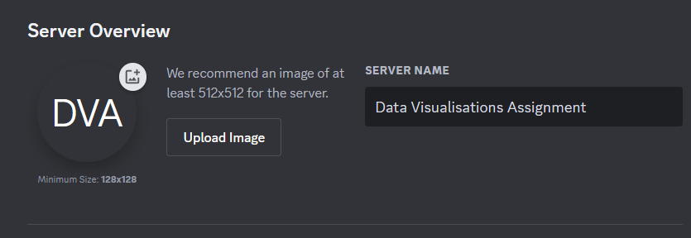

**Timeline of milestones and tasks to be achieved:**

Week 9: project standup and chose dataset for design and development

Week 10: produce our designs and work on the process book + project stand up

Week 11: begin development of our website and visualizations

Week 12 : Finalizing website development + project standup

Week 13: Submission

# Project Standup 2 (data and design):

**Week 10 progress report:**

We have chosen 4 datasets from OECD to create some designs for our D3 visualization. We will need to pick 3 of our favorite designs to include for our website. We have also begun our process book which will describe how we manipulated and implemented our datasets as well as why we chose them.

Contributions: we split each task in half both writing up about and explaining our two chosen datasets and designs.